* 1. **Experimental Data: Implementing a Boolean function using a 4:1 MUX:**

|  |  |  |  |  |  |
| --- | --- | --- | --- | --- | --- |
| **A** | **B** | **C** | **F (Theoretical)** | **Data Inputs** | **F (Practical)** |
| 0 | 0 | 0 | 1 | I0 = 1 | 1 |
| 0 | 0 | 1 | 1 | 1 |
| 0 | 1 | 0 | 0 | I1 = 0 | 0 |
| 0 | 1 | 1 | 0 | 0 |
| 1 | 0 | 0 | 0 | I2 = C | 0 |
| 1 | 0 | 1 | 1 | 1 |
| 1 | 1 | 0 | 0 | I3 = C | 0 |
| 1 | 1 | 1 | 1 | 1 |

**Table F.1.1**

* 1. **Experimental Data: Using an 8:1 MUX to implement a Boolean function:**

|  |  |  |  |  |  |  |
| --- | --- | --- | --- | --- | --- | --- |
| **A** | **B** | **C** | **D** | **F (Theoretical)** | **Data Inputs** | **F (Practical)** |
| 0 | 0 | 0 | 0 | 1 | I0 = 1 | 1 |
| 0 | 0 | 0 | 1 | 1 | 1 |
| 0 | 0 | 1 | 0 | 0 | I1 = D | 0 |
| 0 | 0 | 1 | 1 | 1 | 1 |
| 0 | 1 | 0 | 0 | 0 | I2 = D | 0 |
| 0 | 1 | 0 | 1 | 1 | 1 |
| 0 | 1 | 1 | 0 | 0 | I3 = 0 | 0 |
| 0 | 1 | 1 | 1 | 0 | 0 |
| 1 | 0 | 0 | 0 | 1 | I4 = 1 | 1 |
| 1 | 0 | 0 | 1 | 1 | 1 |
| 1 | 0 | 1 | 0 | 0 | I5 = 0 | 0 |
| 1 | 0 | 1 | 1 | 0 | 0 |
| 1 | 1 | 0 | 0 | 0 | I6 = 0 | 0 |
| 1 | 1 | 0 | 1 | 0 | 0 |
| 1 | 1 | 1 | 0 | 1 | I7 = 1 | 1 |
| 1 | 1 | 1 | 1 | 1 | 1 |

**Table F.2.1**

* 1. **Experimental Data: 3 to 8 Line Decoder:**

|  |  |  |  |  |  |  |  |  |  |  |  |  |
| --- | --- | --- | --- | --- | --- | --- | --- | --- | --- | --- | --- | --- |
| **Enable Inputs** | | **Select Inputs** | | | **Outputs** | | | | | | | |
| **G1** | **G2** | **C** | **B** | **A** | **Y0** | **Y1** | **Y2** | **Y3** | **Y4** | **Y5** | **Y6** | **Y7** |
| X | H | X | X | X | H | H | H | H | H | H | H | H |
| L | X | X | X | X | H | H | H | H | H | H | H | H |
| H | L | L | L | L | L | H | H | H | H | H | H | H |
| H | L | L | L | H | H | L | H | H | H | H | H | H |
| H | L | L | H | L | H | H | L | H | H | H | H | H |
| H | L | L | H | H | H | H | H | L | H | H | H | H |
| H | L | H | L | L | H | H | H | H | L | H | H | H |
| H | L | H | L | H | H | H | H | H | H | L | H | H |
| H | L | H | H | L | H | H | H | H | H | H | L | H |
| H | L | H | H | H | H | H | H | H | H | H | H | L |

**Table F.3.1**

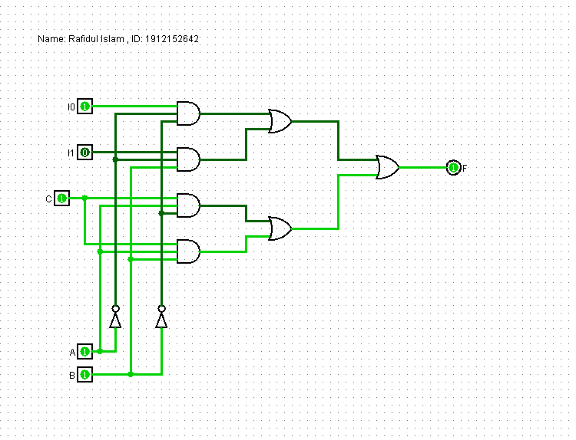

**4:1 MUX**

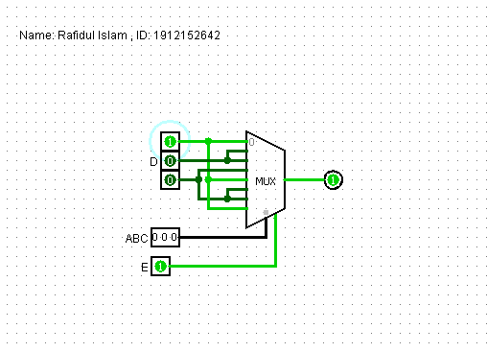

**8:1 MUX**

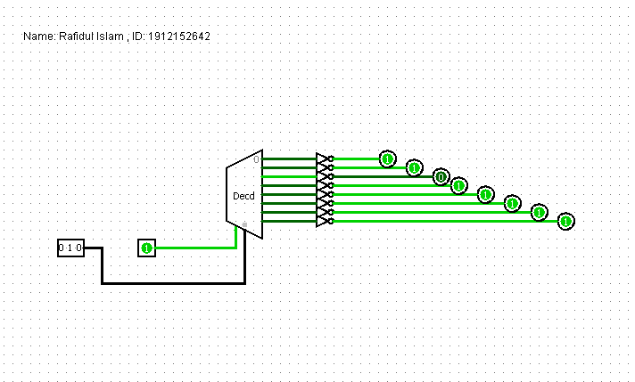

**3 to 8 Line Decoder**